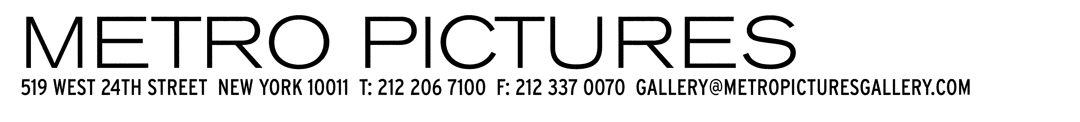

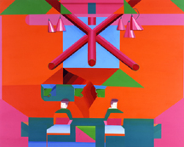

Keegan McHargue: The Control Group
September 21 – October 28, 2006

Metro Pictures is pleased to announce the solo exhibition of the San Francisco-based artist Keegan McHargue, “The Control Group.”

The show will consist of 12 paintings and 12 works on paper all rendered in a flat style with carefully chosen colors ranging from fluorescents to khakis. McHargue’s unique vocabulary mixes disparate themes and presents them as coherent ensembles.

McHargue mixes figurative and abstract elements that come together in repeated patterns offering a poignant gaze into the condition of his subject whether it is a patient in a hospital bed or the stillness of two ceramic bowls. McHargue has said of this body of work:“The Control Group is an art exhibition that reflects my desire to become more a director than a draftsperson. The show is intended to break away from using my own emotional experience as subject matter for my work by hiring an imagined cast of actors and letting them inhabit the character of the artist to represent the many facets of the contemporary human experience. My hope is to reflect my belief in the world as a theatrical experience, a stage in which information will play itself out before the viewer’s eyes.”

Keegan McHargue was born in 1982 in Portland, Oregon and currently lives andworks in San Francisco. His work has been shown in museums and galleries throughout the U.S., Europe and Japan and is included in the collections of the Museum ofModern Art, New York and the Deste Foundation of the Contemporary Arts, Athens.

An opening reception will be held on Thursday, September 21, from 6 – 8pm.

Gallery Hours are 10am – 6pm, Tues – Sat. T: 212 206 7100 www.metropicturesgallery.com

Upcoming exhibitions opening September 30, John Miller, November 4: Robert Longo

Image: Keegan McHargue, Untitled, 2006 acrylic on wood panel

